INSTRUCTIONS FOR SUBSCRIBING FOR THE STAATSOLIE BOND 2020
The subscription form is available on the websites www.dsb.sr or www.staatsolie.com.
STEP 1: Download the form.

STEP 2: Complete the form and save the completed form on your computer.

If you reside in Suriname and have a bank account in Suriname.
➔ Go to STEP 3

If you reside in another country (then Suriname).
➔ Go to STEP 4

STEP 3:

If you are not a DSB client:
Print the completed form, sign it and submit the subscription form to the bank of your choice. All local banks participate in this registration. Upon submission of the subscription form please have the identification you provided on your subscription form available for verification purposes.

If you are a DSB client and do not have Internet Banking:
Print the completed form, sign it and submit the subscription form to DSB. Upon submission of the subscription form please have the identification you provided on your subscription form available for verification purposes.

If you are a DSB client and do have Internet Banking:
You can submit the completed subscription form digitally.
If using the DSB Internet Banking platform for subscription the following applies:
- For subscription by legal persons, no signature is required.
- For subscriptions by others (then legal persons) the subscription form must be legally signed in accordance with the articles of association.
The steps to subscribe via Internet Banking are as follows:
- Log in to DSB Internet Banking and click on the envelope (bank mail).

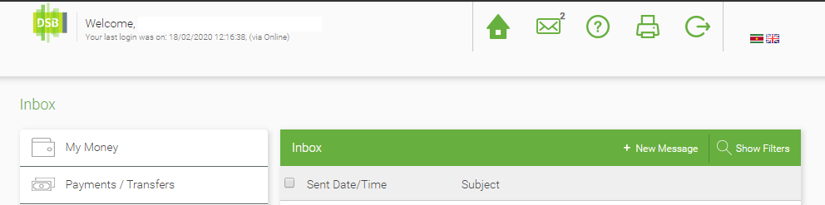

- Click ‘New Message’ to create a new message.
At ‘Topic’ choose ‘Other’.
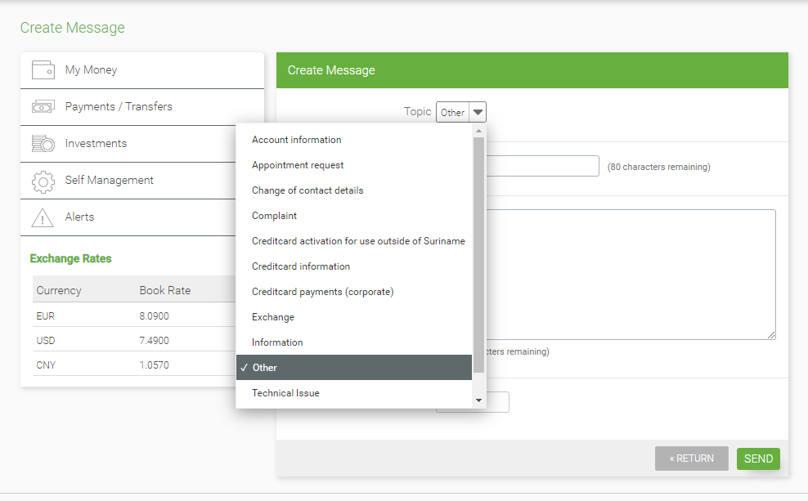
- After choosing ‘Other’ type in ‘Staatsolie Bond 2020’ at ‘Subject’.
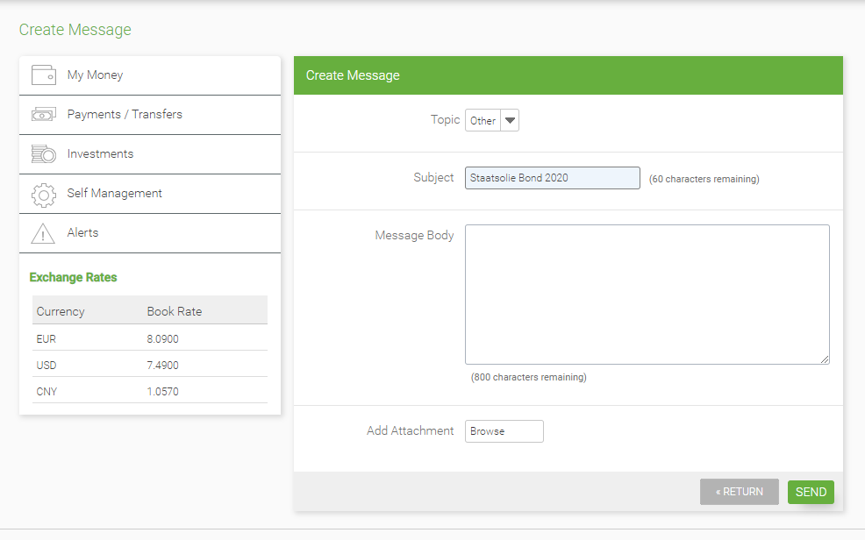
- At “Message Body” type in:
‘Dear DSB,
Please find attached my subscription for the Staatsolie Bond 2020.’

Regards,
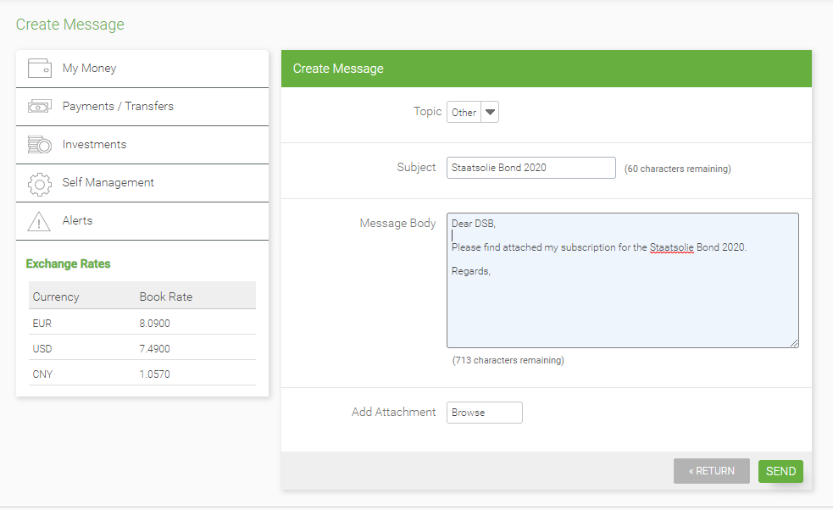
- Next, by using the option ‘Add Attachment’ the subscription form can be attached.
- Press the ‘Send’ button.
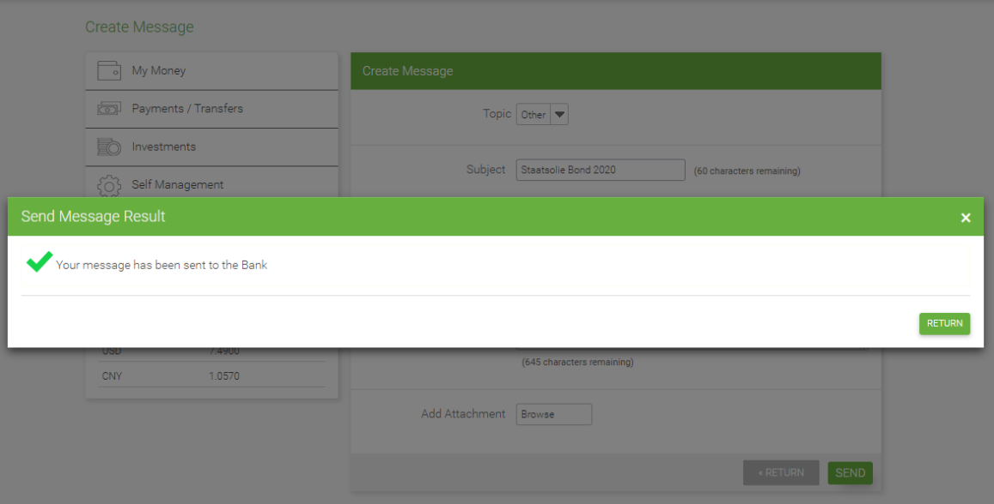
CONGRATULATIONS, you have subscribed for the Staatsolie Bond 2020!
If there are any questions regarding your subscription, DSB will contact you.
In the allotment period, from 6 March until 8 March 2020, all subscribers will be notified by SMS and e-mail whether the Bonds which they have subscribed for have been allotted to them.
The payment period is from 9 March until 20 March 2020. During this period, the USD account specified on the subscription form, will be debited for the payment of the allotted bonds.

STEP 4: Instructions for subscribing in case you are not residing in Suriname.

STEP 1: Download the form.

STEP 2: Complete the form and save the completed form on your computer.
If you wish to subscribe and:
- have an account at DSB and Internet Banking
- Go to STEP 3c as described above.
If you have a bank account outside of Suriname and you are interested to invest offshore in the Staatsolie Bonds, please contact one of the Authorized Brokers:
- DSB via one of the following e-mail addresses:
- info.staatsobligatie@dsb.sr
- gregory.smart@dsb.sr
or
- Vidanova Bank via one of the following e-mail addresses:
  - investmentservices@vidanovabank.com
  - jtexel@vidanovabank.com
  - sisenia@vidanovabank.com

