CONFIDENTIALITY AGREEMENT

This CONFIDENTIALITY AGREEMENT ("Agreement") is effective [DATE], (“Effective Date”) by and between:

- STAATSOLIE MAATSCHAPPIJ SURINAME N.V., having its registered office at Dr. Ir. H.S. Adhinstraat 21, Paramaribo, Suriname, a company organized and existing under the laws of Suriname ("Disclosing Party"), and
- [COMPANY NAME], having its registered office at [ADDRESS], a company organized and existing under the laws of [COUNTRY] ("Receiving Party")

Hereinafter individually referred to as a "Party" and collectively as "Parties".

AGREE as follows:

1. Confidential Information

1. Disclosing Party is willing, in accordance with the terms and conditions of this Agreement, to disclose (either through itself or its representatives) to the Receiving Party (or its representatives) certain data owned by Disclosing Party in the area described in Exhibit A (“Area”), on a non-exclusive basis (“Confidential Information”).

2. The Confidential Information relating to the Area may include, but is not necessarily limited to originals and copies of geological and geophysical data, maps, models, analyses, derivatives and interpretations and may also include commercial, contractual and financial information.

3. The Receiving Party shall acquire no proprietary interest in or right to the Confidential Information which shall remain the property of the Disclosing Party.

2. Non-disclosure

In consideration of the disclosure referred to in Clause 1, the Receiving Party agrees that it:
- shall keep the Confidential Information strictly confidential and it shall not sell, trade, publish or otherwise disclose the Confidential Information to anyone in any manner whatsoever, including by means of photocopy, reproduction or electronic media, without the Disclosing Party's prior written consent, except as provided in Clause 4;
- shall not use any of the Confidential Information in any way detrimental or adverse to the Disclosing Party or any of its Affiliated Companies (as hereinafter defined in clause 4.2.), or otherwise cause loss or damage to the Disclosing Party or its Affiliated Companies.

3. Non-confidential Information

The following shall not constitute Confidential Information:

- information that is already known to Receiving Party or its Affiliated Companies as of the Effective Date;
- information that is or becomes available to the public other than through the act or omission of Receiving Party or of any other person to whom Confidential Information is disclosed by Receiving Party unless public disclosure was made pursuant to Clause 4.1.;
- information that is acquired independently from a third party representing that it has the right to disseminate such information at the time it is acquired by the Receiving Party; or,
d) information that is developed independently by Receiving Party of the Confidential Information received from Disclosing Party.

4. Permitted Disclosure By Receiving Party

Receiving Party may disclose the Confidential Information without the prior written consent of Disclosing Party:

- To the extent the Confidential Information must be disclosed under applicable law, by a governmental order, decree, regulation or rule, by the order of any court of competent jurisdiction provided that Receiving Party shall make all reasonable efforts to give prompt written notice to Disclosing Party prior to such disclosure.

To the following persons to the extent that Receiving Party needs them to evaluate the Area or to determine whether to enter into negotiations concerning the acquisition of certain rights of Disclosing Party in the Area:

a. Employees, officers, and directors of an Affiliated Company of Receiving Party, provided that the Receiving Party guarantees the adherence of such persons to the terms of this Agreement. "Affiliated Company" means any company or legal entity which (a) controls either directly or indirectly a Party, or (b) which is controlled directly or indirectly by such Party, or (c) is directly or indirectly controlled by a company or entity which directly or indirectly controls such Party. "Control" means the right to exercise 50% or more of the voting rights in the appointment of the directors of such company or entity.

b. Employees, officers and directors of the Receiving Party;

c. Any professional consultant or agent retained by the Receiving Party for the purpose of evaluating the Confidential Information; or,

d. any bank or other financial institution or entity funding or proposing to fund the Receiving Party's, or its Affiliated Companies, participation in the Area, including any consultant retained by such bank or other financial institution or entity.

3. Prior to making any such disclosures to persons under Clause 4.2.c or 4.2.d, the Receiving Party shall obtain an undertaking of confidentiality, enforceable by both the Disclosing Party and the Receiving Party, substantially in the same form and content as this Agreement, from each such person. However, in the case of external legal counsel, the Receiving Party shall only be required to procure that such legal counsel is bound by an obligation of confidentiality.

4. Receiving Party shall be responsible to Disclosing Party for any act or omission of the entities and persons described in Clause 4.2 that would have breached this Agreement if the action had been by Receiving Party.

5. Restriction on Use of Confidential Information

- Receiving Party shall only use or permit the use of the Confidential Information to:
(1) Evaluate the Area by Receiving Party.
(2) De-risk their petroleum operations of the Receiving Party,

- The Parties recognize that persons authorized to review the Confidential Information under Clause 4.2 may form mental impressions (i.e., impressions not written or otherwise reduced to a record) regarding the Confidential Information. The use of these mental impressions by those persons shall not be a violation of the restriction contained in Clause 5.1.

6. Damages

The liability of the Parties to each other for breach of this Agreement shall be limited to direct actual damages only. Such direct actual damages shall be the sole and exclusive remedy, and all other remedies or damages at law or in equity are waived except such equitable relief as may be granted under Clause 13. In no event shall the Parties be liable to each other for any other damages, including loss of profits or incidental, consequential, special, or punitive damages, regardless of negligence or fault.

7. Term and Return of Confidential Information
- This Agreement shall terminate 5(five) years after the date of this Agreement.
- Upon termination of this Agreement, Receiving Party shall destroy or cause to be destroyed all copies in its possession and in the possession of persons to whom it was disclosed pursuant to this Agreement. Further hereto, the Receiving Party will provide a statement indicating that all of the original Confidential Information is returned or destroyed.
- Notwithstanding Clause 7.2,
a. It is understood that Receiving Party’s computer systems (and the computer systems of those persons to whom Confidential Information was disclosed) may be periodically backed up creating copies of all information resident in these systems. To the extent the computer back-up procedures create a copy which includes Confidential Information, Receiving Party may retain such copy for the period it normally archives back-up computer records. The terms of this Agreement pertaining to the disclosure and the confidentiality of the Confidential Information shall survive and be applicable until the information on such back-up copy/record is destroyed.
b. To the extent the Confidential Information must be retained under applicable law, including by stock exchange regulations or by governmental order, decree, regulation or rule, Receiving Party may then retain such copy of the Confidential Information and will notify Disclosing Party of such retention.

- In the event of a breach to this agreement, the Disclosing Party may demand the return of Confidential Information at any time upon giving written notice to the Receiving Party. Within 30 (thirty) days of receipt of such notice, the Receiving Party shall return all of the original Confidential Information and shall destroy all copies and reproductions (both written and electronic) in its possession and in the possession of persons to whom the Confidential Information was disclosed (including its Affiliated Companies).

8. Evaluation Material

1. Information generated by Receiving Party or by a person described in Clause 4.2 that is derived in whole or in part from Confidential Information is “Evaluation Material.” Evaluation Material includes models, analyses, estimates of reserves, interpretations, presentations for management, and economic evaluations.

2. During the term of this Agreement, Receiving Party shall not disclose Evaluation Material to anyone other than the persons described under Clause 4 without the prior written consent of Disclosing Party.

9. Representations and Warranties

1. Disclosing Party represents and warrants that it has the right and authority to disclose the Confidential Information to Receiving Party and allow Receiving Party and its Affiliated Companies to use the Confidential Information in accordance with this Agreement.
2. Disclosing Party makes no representations or warranties, express or implied, as to the quality, accuracy and adequacy of the Confidential Information, and Receiving Party expressly acknowledges the inherent risk of error in the acquisition, processing, and interpretation of geological and geophysical data. Disclosing Party, its Affiliated Companies, their officers, directors and employees shall have no liability whatsoever regarding the use of or reliance upon the Confidential Information by Receiving Party.

10. Assignment of This Agreement

The Receiving Party may assign this Agreement to an Affiliated Company, provided that the Receiving Party remains liable for all obligations under this Agreement. Receiving Party may assign this Agreement to a person or entity that is not an Affiliated Company only with the prior written approval of Disclosing Party. Any attempted assignment by Receiving Party to a person or entity that is not an Affiliated Company without the prior written approval of Disclosing Party shall be void. Without limiting the prior provisions of this Clause 11, this Agreement shall bind and inure to the benefit of the Parties and their respective successors and permitted assigns.

11. Notices

All notices authorized or required between the Parties by any of the provisions of this Agreement shall be in written English, properly addressed to the other Party as shown below, and delivered in person, by courier, or by any electronic means of transmitting written communications that provides written confirmation of complete transmission. Oral communication do not constitute notice for purposes of this Agreement.

DISCLOSING PARTY | RECEIVING PARTY
Address: Dr. Ir. H.S. Adhinstraat 21  Paramaribo, Suriname  Attention: Vandana Gangaram Panday | Address:  Attention:

12. Governing Law and Dispute Resolution

- This Agreement shall be governed by and interpreted in accordance with the substantive laws of Suriname excluding any choice of law rules which would refer the matter to the laws of another jurisdiction.
- Any dispute arising out of, relating to, or in connection with this Agreement, including any question regarding its existence, validity, or termination shall be settled before a sole arbitrator in accordance with the Arbitration Rules of the International Chamber of Commerce (the “ICC”). The seat of the arbitration shall be in Amsterdam, The Netherlands. The proceedings shall be in the English language and the arbitral award rendered in the Dutch and the English languages. The resulting arbitral award shall be final and binding without right of appeal, and judgment upon such award may be entered in any court having jurisdiction thereof.
- A dispute shall be deemed to have arisen when either Party notifies the other Party in writing to that effect. Each Party acknowledges that remedies at law may be inadequate to protect against breach of this Agreement; accordingly, the arbitrator may award both monetary and equitable relief, including injunctive relief and specific performance.
A Party may apply to any competent judicial authority for interim or conservatory relief; an application for such measures or an application for the enforcement of such measures ordered by the arbitrator shall not be deemed an infringement or waiver of the Agreement to arbitrate and shall not affect the powers of the arbitrator. Any monetary award issued by the arbitrator shall be payable in U.S. dollars.

13. Delivery and Timing

Disclosing Party shall deliver the Confidential Information to Receiving Party upon receipt of the Compensation by Disclosing Party. The Receiving Party shall within a reasonable timeframe, following delivery of the Confidential Information, notify Disclosing Party of missing data or any defects including but not limited to (i) corrupt files and (ii) corrupt or faulty data headers. Disclosing Party shall re-deliver the applicable Confidential Information within a reasonable timeframe, without prejudice to other remedies Receiving Party may have.

14. General Provisions

- No Waiver
No waiver by either Party of any one or more breaches of this Agreement by the other Party shall operate or be construed as a waiver of any future default or defaults by the same Party. Neither Party shall be deemed to have waived, released, or modified any of its rights under this Agreement unless such Party has expressly stated, in writing, that it does waive, release or modify such rights.

2. No Third Party Beneficiaries
The interpretation of this Agreement shall exclude any rights under legislative provisions conferring rights under a contract to persons not a party to that contract.

IN WITNESS of their agreement each Party has caused its duly authorized representative to sign this instrument effective on the date first written above.

[COMPANY NAME]

[NAME]
[TITLE]

EXHIBIT "A"

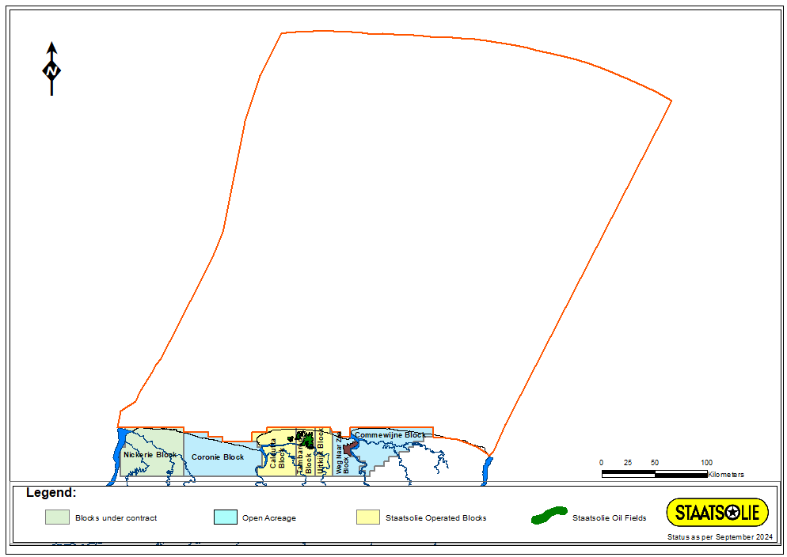
Map showing the area (red outlined) containing the data as specified in the data catalog

